When the experimental material is not homogeneous the LSD is better than RBD. In RBD local control is used according to one way grouping. i.e according to blocks but in LSD local control is used according to two way grouping i.e. rows and columns. Hence it is used when two sources of errors are to be controlled simultaneously. In this design number of treatments are equal to the number of replication and the treatment occurs once and only once in each row and column. In this design, Latin alphabet are used to denote the treatments, and shape is square due to equal number of treatments and replication so called Latin Square design. It is based upon the all principles of design namely replication, randomization and local control.

Let us consider m treatments with m replication each so that there are N = m2 experiments unit.

Let us divide the experimental material into m2 experimental units arranged in square so that each row as well as column contains m units. In this design none of  treatments are replicated along row wise or column wise. In this case we study the variation between treatments, the variation between rows and variations between columns. It has only m2 experimental treatments. Hence it is the case of incomplete three ways ANOVA. for complete three way ANOVA, we need m3 experimental unit.

Let us consider t = 3(A, B, C, ) then 3x3 LSD is as shown below.

**Example Layout (3×3 Latin Square):**

|  | **Column 1** | **Column 2** | **Column 3** |
| --- | --- | --- | --- |
| Row 1 | A | B | C |
| Row 2 | B | C | A |
| Row 3 | C | A | B |

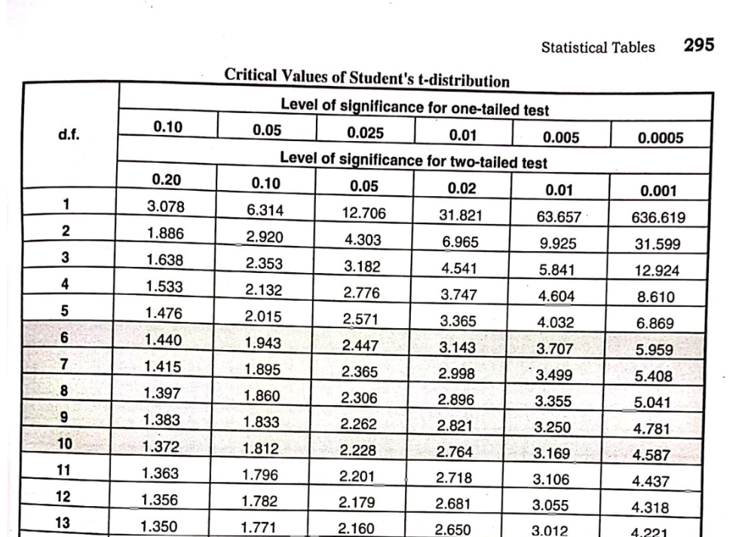Where A, B, C represent different treatments.

**3. Why Number of Treatments Should Not Be Less Than 3**

**1.Statistical Power**: With fewer than 3 treatments, it’s difficult to establish meaningful patterns or draw valid conclusions.2.**Variability Control**: Latin Squares are designed to control two sources of variability (rows and columns). With only 2 treatments, the design reduces to a simple block design, losing its advantage.3.**Balance**: The design requires each treatment to appear once in each row and column. With 2 treatments, the design becomes trivial and less effective in controlling variability.

**Application Example:Scenario:** Testing the effect of 3 different fertilizers (A, B, C) on crop yield, while controlling for soil type (rows) and irrigation method (columns).**Latin SquareLayout:**

| **Soil Type \ Irrigation** | **Drip** | **Sprinkler** | **Flood** |
| --- | --- | --- | --- |
| Sandy | A | B | C |
| Loamy | B | C | A |
| Clay | C | A | B |

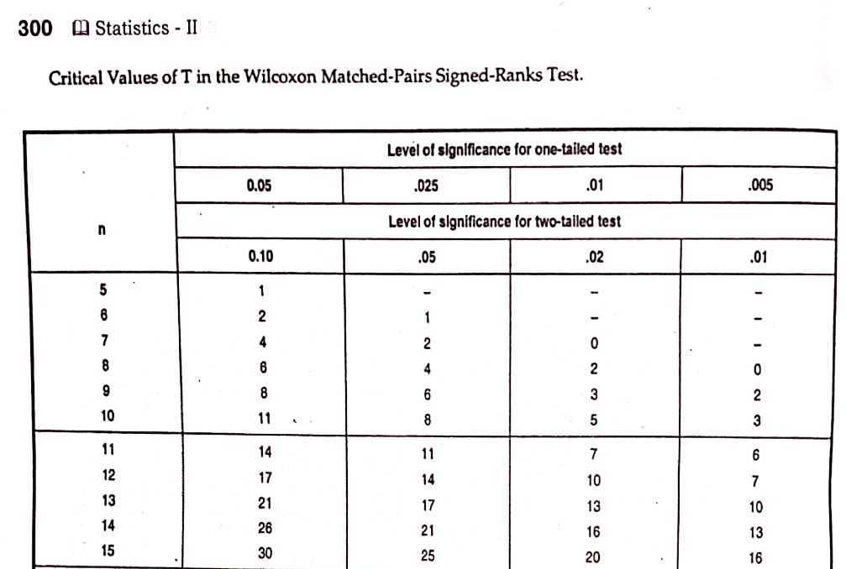

**5. Advantages of Latin Square Design1.**Controls two sources of nuisance variability2.Requires fewer experimental runs3.Provides balanced and orthogonal comparisons

**6. Limitations**1.Not suitable for interactions between factors2.Requires equal number of rows, columns, and treatments3.Becomes impractical for large numbers of treatments

**Conclusion:** The Latin Square Design is a powerful tool when you need to control two sources of variation simultaneously, but it requires at least 3 treatments to be effective. This design is particularly useful in agricultural, industrial, and clinical experiments where multiple sources of variability need to be accounted for.

**Type I Error (False Positive)**:

Type I error occurs when a null hypothesis that is actually true is incorrectly rejected. In other words, it’s a false positive result.

This error is often denoted as α (alpha), which represents the level of significance, and it indicates the probability of making a Type I error.

Type I errors are considered more serious in situations where making an incorrect rejection of the null hypothesis has significant consequences or costs. For example, in medical testing, a Type I error might mean diagnosing a healthy person as having a disease.**Type II Error (False Negative)**:

Type II error occurs when a null hypothesis that is actually false is incorrectly not rejected. It’s a false negative result.

This error is often denoted as β (beta) and is used to represent the probability of making a Type II error.

Type II errors can be problematic when failing to reject the null hypothesis means that a real effect or relationship goes undetected. For example, in medical testing, a Type II error might mean failing to diagnose a person who actually has a disease.



|  |  |
| --- | --- |
| P-tests | NP-tests |
| The tests whose models specify certain conditions about parameters of the population from which the sample has been drawn. | The tests whose models don’t specify any conditions about parameters of population from which sample has been drawn. |
| Mostly applied only to the data measured in ratio and interval scale. | Mostly only applied to data measured in nominal and ordinal scale. |
| Most powerful. | Weaker. |
| Designed to test the statistical hypothesis of one or more parameters of population. | Designed to test statistical hypothesis which don’t involve any parameters of population. |





**Stochastic process.**

A stochastic process, also known as a random process, is a mathematical concept used in probability theory and statistics to model and analyze the evolution of a system or a phenomenon over time. It’s essentially a collection of random variables, each of which represents a state or an outcome at a specific point in time. Here are some key points about stochastic processes:

**Random Variables Over Time:** A stochastic process involves random variables that evolve with time. Each random variable represents the state of the system or process at a particular time point.

**Sequential Nature:** Stochastic processes are inherently sequential in nature. You can think of them as a sequence or a collection of random events or observations that unfold over time.

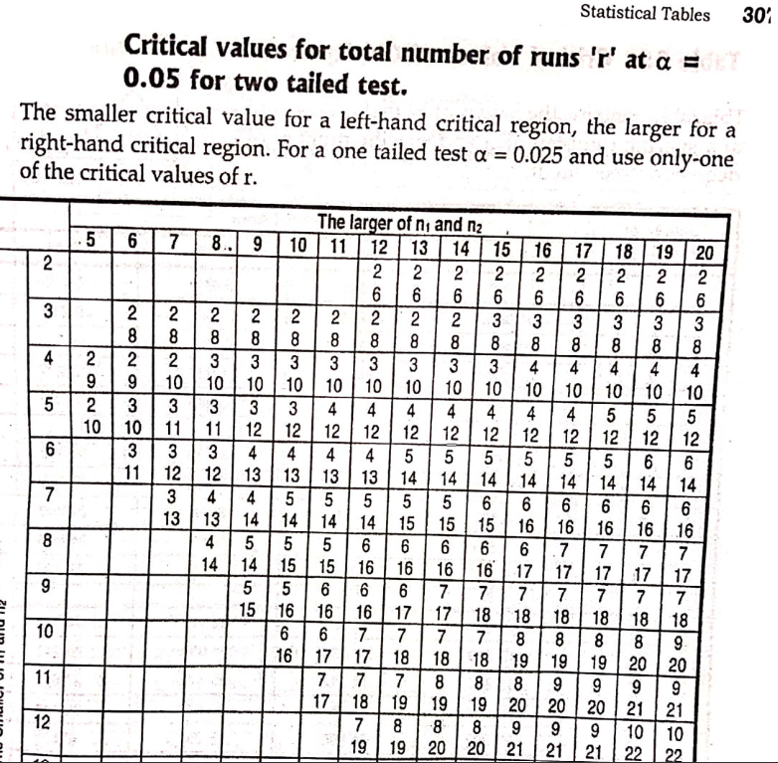

**Classification:** Stochastic processes can be classified into different types based on various characteristics. Common classifications include discrete-time vs. continuous-time processes, stationary vs. non-stationary processes, and Markov vs. non-Markov processes, among others.

**Applications:** Stochastic processes find applications in various fields, such as finance, physics, engineering, biology, and economics. For example, in finance, they are used to model stock prices, in physics to simulate random motion, and in biology to study population dynamic.



**Markov Property:** In a Markov process, the future behavior of the process depends only on its present state and not on its past states. This property is often used to simplify the analysis of stochastic processes.

**Examples:** Common examples of stochastic processes include the Poisson process (used to model the arrival of events over time), Brownian motion (used to describe random motion), and autoregressive integrated moving average (ARIMA) models (used for time series analysis).

**Modeling and Analysis:** Stochastic processes are used to model uncertainty and randomness in real-world phenomena. They allow researchers and analysts to make probabilistic predictions and assess the likelihood of various outcomes.

**Simulation:** Stochastic processes are often used in Monte Carlo simulations, a technique for estimating the behavior of complex systems by repeatedly sampling random variables to understand the range of possible outcomes.

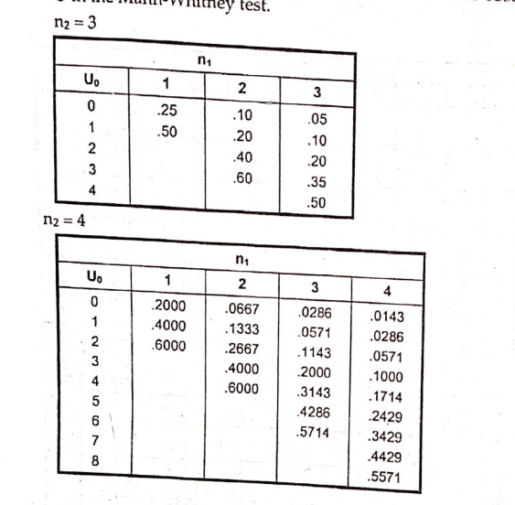

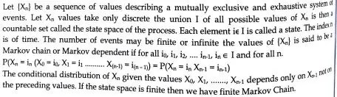

i. It is a mathematical system experiences transitions from one state to another according to certain probabilistic rules.

ii. No matter how the process arrived at its present state, the possible future states are fixed i.e. the probability of transitioning to any particular state is dependent solely on the current state and time elapsed.

iii. The state space, or set of all possible states, can be anything: letters, numbers, weather conditions, baseball scores, or stock performances.

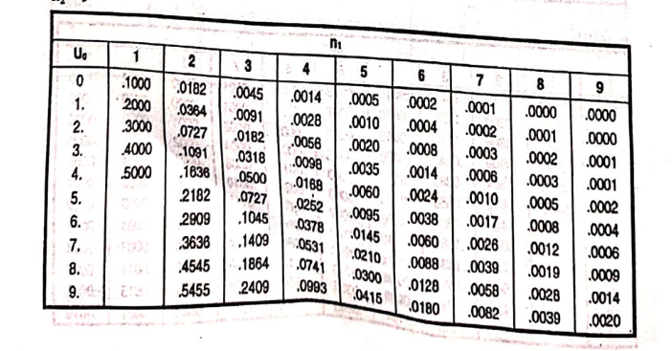

iv. Markov chains may be modeled by finite state machines, and random walks provide a prolific example of their usefulness in mathematics.

v. They arise broadly in statistical and information-theoretical contexts and are widely employed in economics, game theory, queueing (communication) theory, genetics, and finance.

vi. While it is possible to discuss Markov chains with any size of state space, the initial theory and most applications are focused on cases with a finite (or countably infinite) number of states.

vii. Many uses of Markov chains require proficiency with common matrix methods.

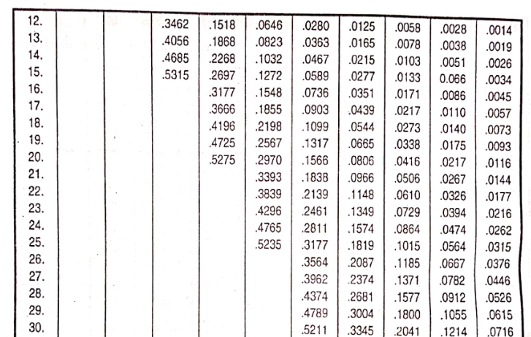

**ii. Properties of a good estimator1. Unbiasedness.**

An estimator is said to be unbiased if its expected value is identical with the population parameter being estimated. That is if θ is an unbiased estimate of θ, then we must have E (θ) = θ. Many estimators are “Asymptotically unbiased” in the sense that the biases reduce to practically insignificant value (Zero) when n becomes sufficiently large. The estimator S2 is an example.  
It should be noted that bias is estimation is not necessarily undesirable. It may turn out to be an asset in some situations.**Consistency.**If an estimator, say θ, approaches the parameter θ closer and closer as the sample size n increases, θ is said to be a consistent estimator of θ. Stating somewhat more rigorously, the estimator θ is said is be a consistent estimator of θ if, as n approaches infinity, the probability approaches 1 that θ will differ from the parameter θ by no more than an arbitrary constant.The sample mean is an unbiased estimator of µ no matter what form the population distribution assumes, while the sample median is an unbiased estimate of µ only if the population distribution is symmetrical. The sample mean is better than the sample median as an estimate of µ in terms of both unbiasedness and consistency. 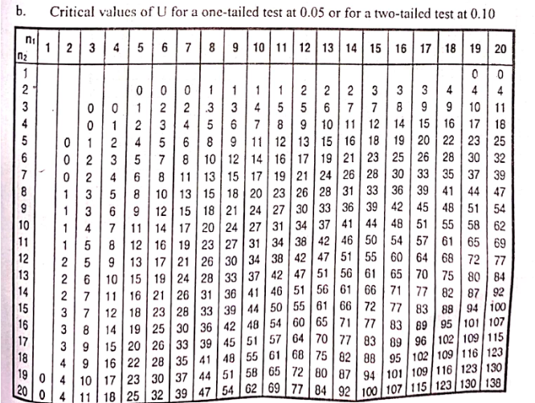

**3. Efficiency.**

The concept of efficiency refers to the sampling variability of an estimator. If two competing estimators are both unbiased, the one with the smaller variance (for a given sample size) is said to be relatively more efficient. Stated in a somewhat different language, an estimator θ is said to be more efficient than another estimator θ2 for θ if the variance of the first is less than the variance of the second. The smaller the variance of the estimator, the more concentrated is the distribution of the estimator around the parameter being estimated and, therefore, the better this estimator is.



**4. Sufficiency.**

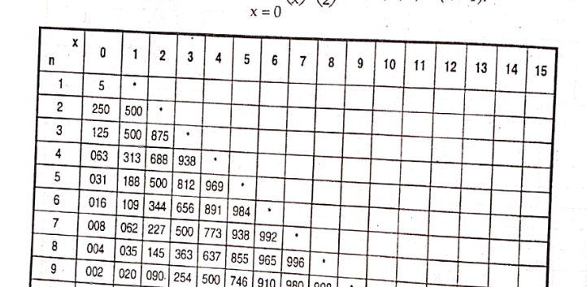An estimator is said to be sufficient if it conveys much information as is possible about the parameter which is contained in the sample. The significance of sufficiency lies in the fact that if a sufficient estimator exists, it is absolutely unnecessary to considered any other estimator; a sufficient estimator ensures that all information a sample a sample can furnished with respect to the estimation of a parameter is being utilized.  
Many methods have been devised for estimating parameters that may provide estimators satisfying these properties. The two important methods are the least square method and the method of maximum likelihood.



**1. Test of Equality of Two Variances**

This test is used to determine whether two populations have equal variances. It is commonly applied before conducting a t-test, where equal variance assumption is required.

* **Hypotheses:**
  + H0H_0H0​: σ12=σ22\sigma_1^2 = \sigma_2^2σ12​=σ22​
  + H1H_1H1​: σ12≠σ22\sigma_1^2 \ne \sigma_2^2σ12​=σ22​
* **Test Statistic (F-test):**

F=s12s22F = \frac{s_1^2}{s_2^2}F=s22​s12​​

Where s12s_1^2s12​ and s22s_2^2s22​ are the sample variances from two groups (with s12>s22s_1^2 > s_2^2s12​>s22​).

* The statistic follows an **F-distribution** with degrees of freedom (n1−1,n2−1)(n_1 - 1, n_2 - 1)(n1​−1,n2​−1).
* **Decision Rule:**  
  Compare the calculated FFF with critical values from the F-distribution table.
  + If FFF lies outside the acceptance region, **reject H0H_0H0​** (i.e., variances are unequal).

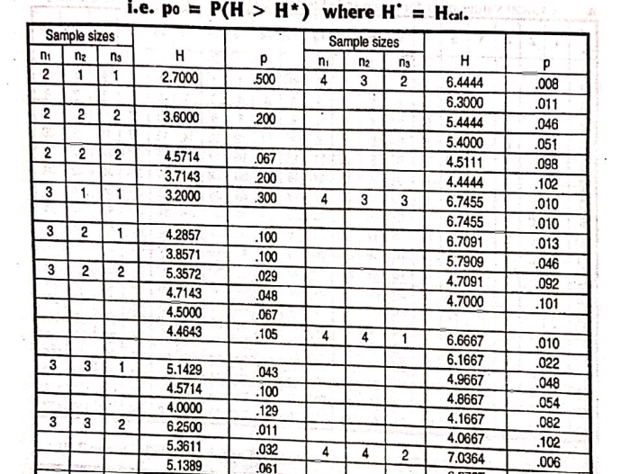

**2. Adjusted R2R^2R2 (Adjusted Coefficient of Determination)**

Adjusted R2R^2R2 is a modified version of R2R^2R2 that adjusts for the number of predictors in a regression model. It is used to judge the goodness of fit while penalizing unnecessary variables.

* **Formula:**

Adjusted R2=1−((1−R2)(n−1)n−k−1)\text{Adjusted } R^2 = 1 - \left( \frac{(1 - R^2)(n - 1)}{n - k - 1} \right)Adjusted R2=1−(n−k−1(1−R2)(n−1)​)

Where:

* + R2R^2R2 = coefficient of determination
  + nnn = sample size
  + kkk = number of predictors**Key Points:**
  + Adjusted R2R^2R2 can **decrease** if a new predictor does not improve the model significantly.
  + It is a better measure than R2R^2R2 when comparing models with different numbers of variables.

